Lab 1 – Setting Up Flutter and Running Your First App
1. Objective
This lab helps students set up the Flutter environment and run their first Flutter application. Students will learn how to install tools, create a project, execute it on a device/emulator, and perform basic UI customization.
2. Requirements
Students must:
- Install Flutter SDK
- Configure IDE (Android Studio or VS Code)
- Create and run a Flutter app
- Customize the layout
- Submit screenshots as evidence
3. Guided Steps
Exercise 1 – Flutter Environment Setup
Goal: Install and verify Flutter tools.
Steps
- Install Flutter SDK.
- Add Flutter to PATH.
- Run:
flutter doctor
- Ensure all items are properly configured.
- Verify Flutter & Dart plugins in Android Studio.
Deliverables
- Screenshot of flutter doctor
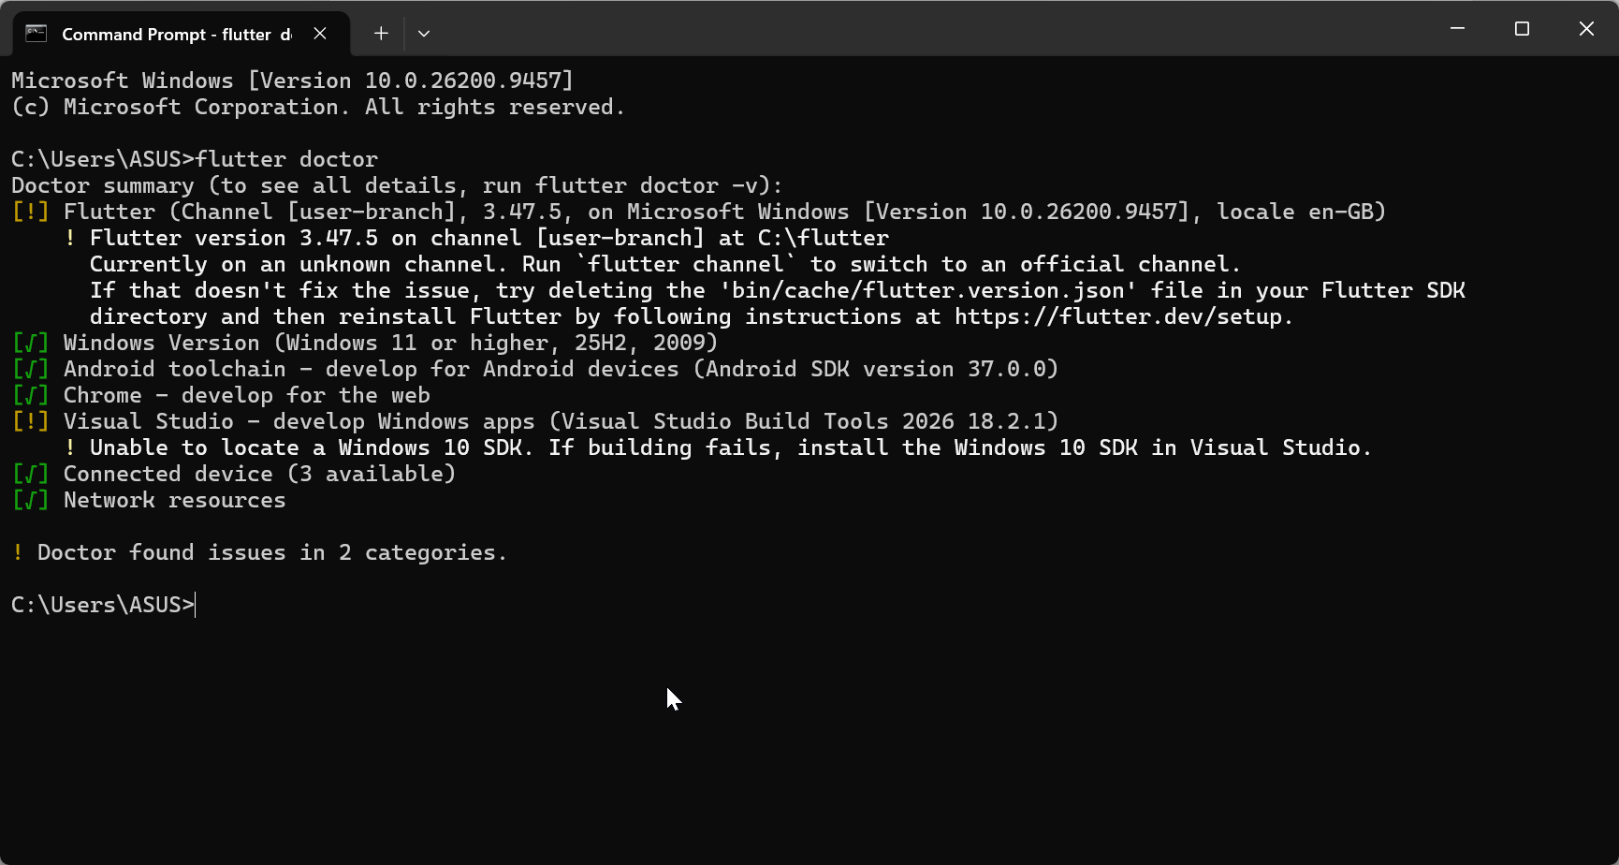
- Screenshot of Flutter/Dart plugin screen
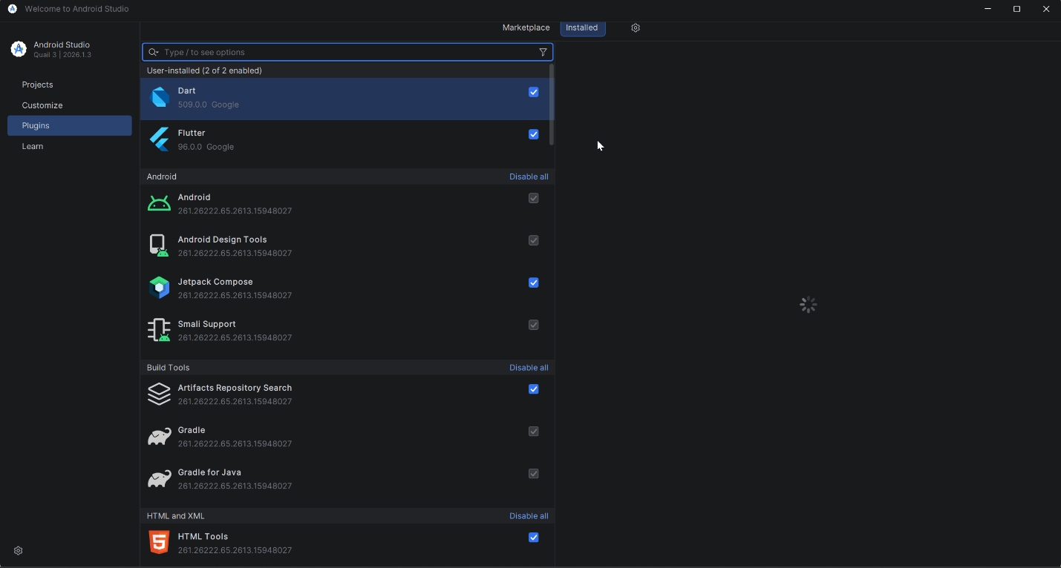

Exercise 2 – Create and Run Your First Flutter App
Goal: Learn how to create a Flutter project and run the default app.
Steps
- Open Android Studio → New Flutter Project
- Use project name: hello_flutter_lab1
- Explore key folders: lib/, android/, ios/, pubspec.yaml
- Start emulator or connect device
- Run the default counter app
- Modify the AppBar title in main.dart:
title: 'My First Flutter App',
- Use Hot Reload and observe changes
Deliverables
- Screenshot of project structure
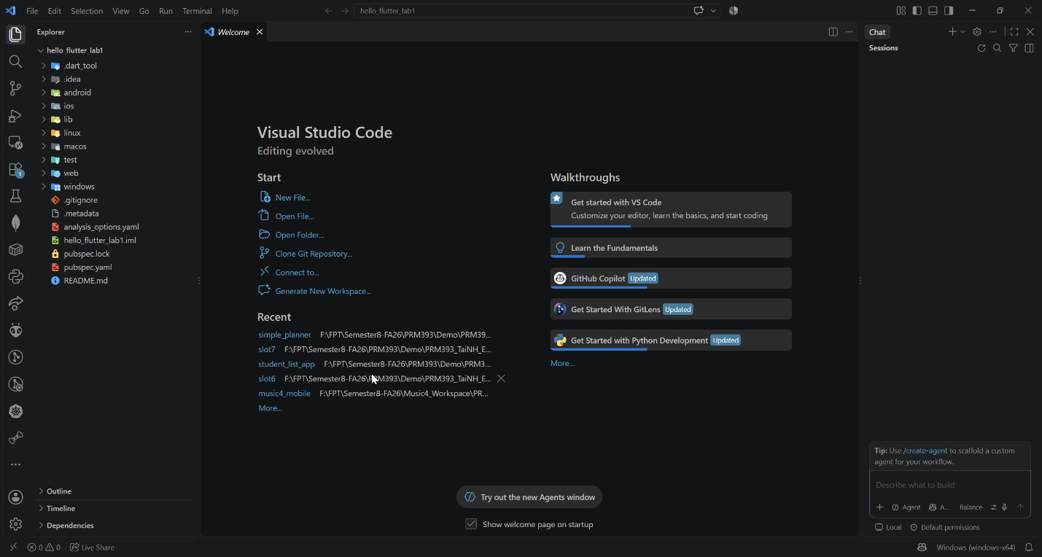
- Screenshot of running counter app
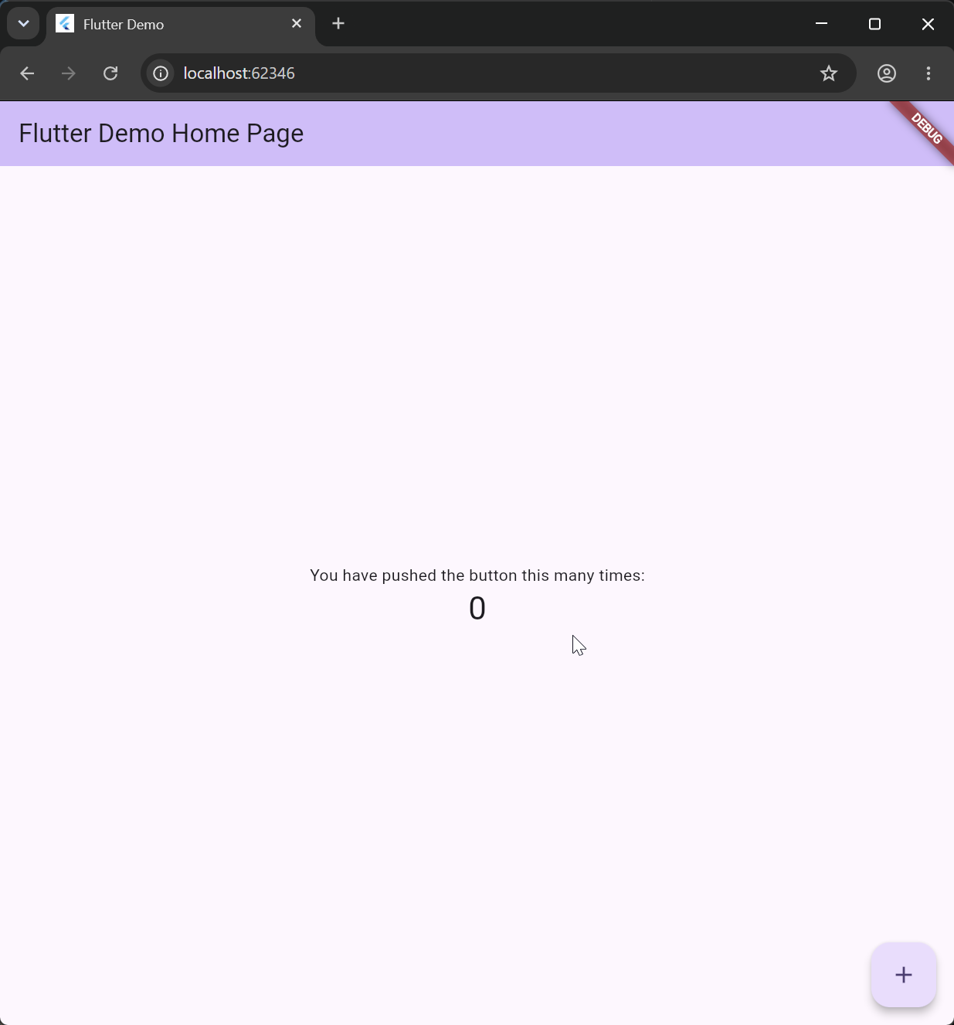
- Screenshot showing updated title via Hot Reload
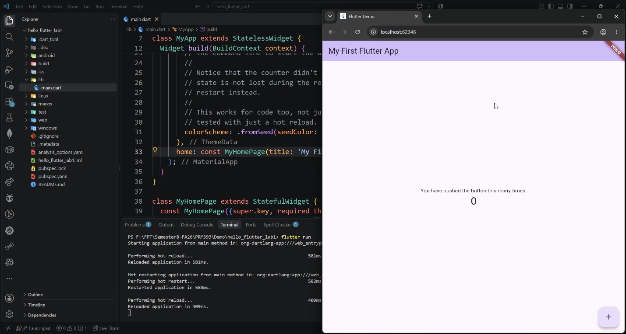

Exercise 3 – Customize Your First Flutter UI
Goal: Build a simple custom UI with widgets learned in class.
Steps
- Replace default code in main.dart with:
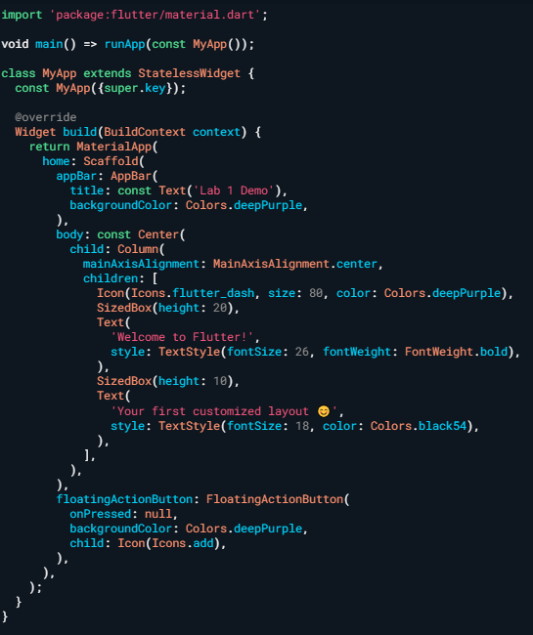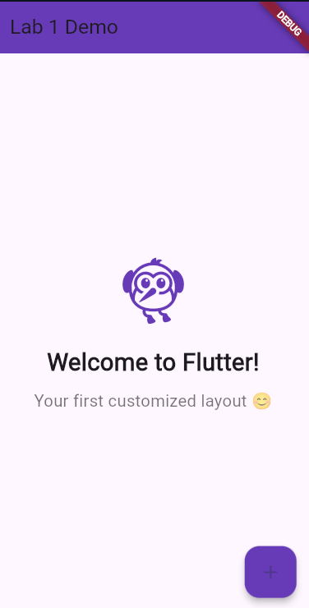
- Perform Hot Reload and verify UI updates.
- Modify colors/text and reload again.
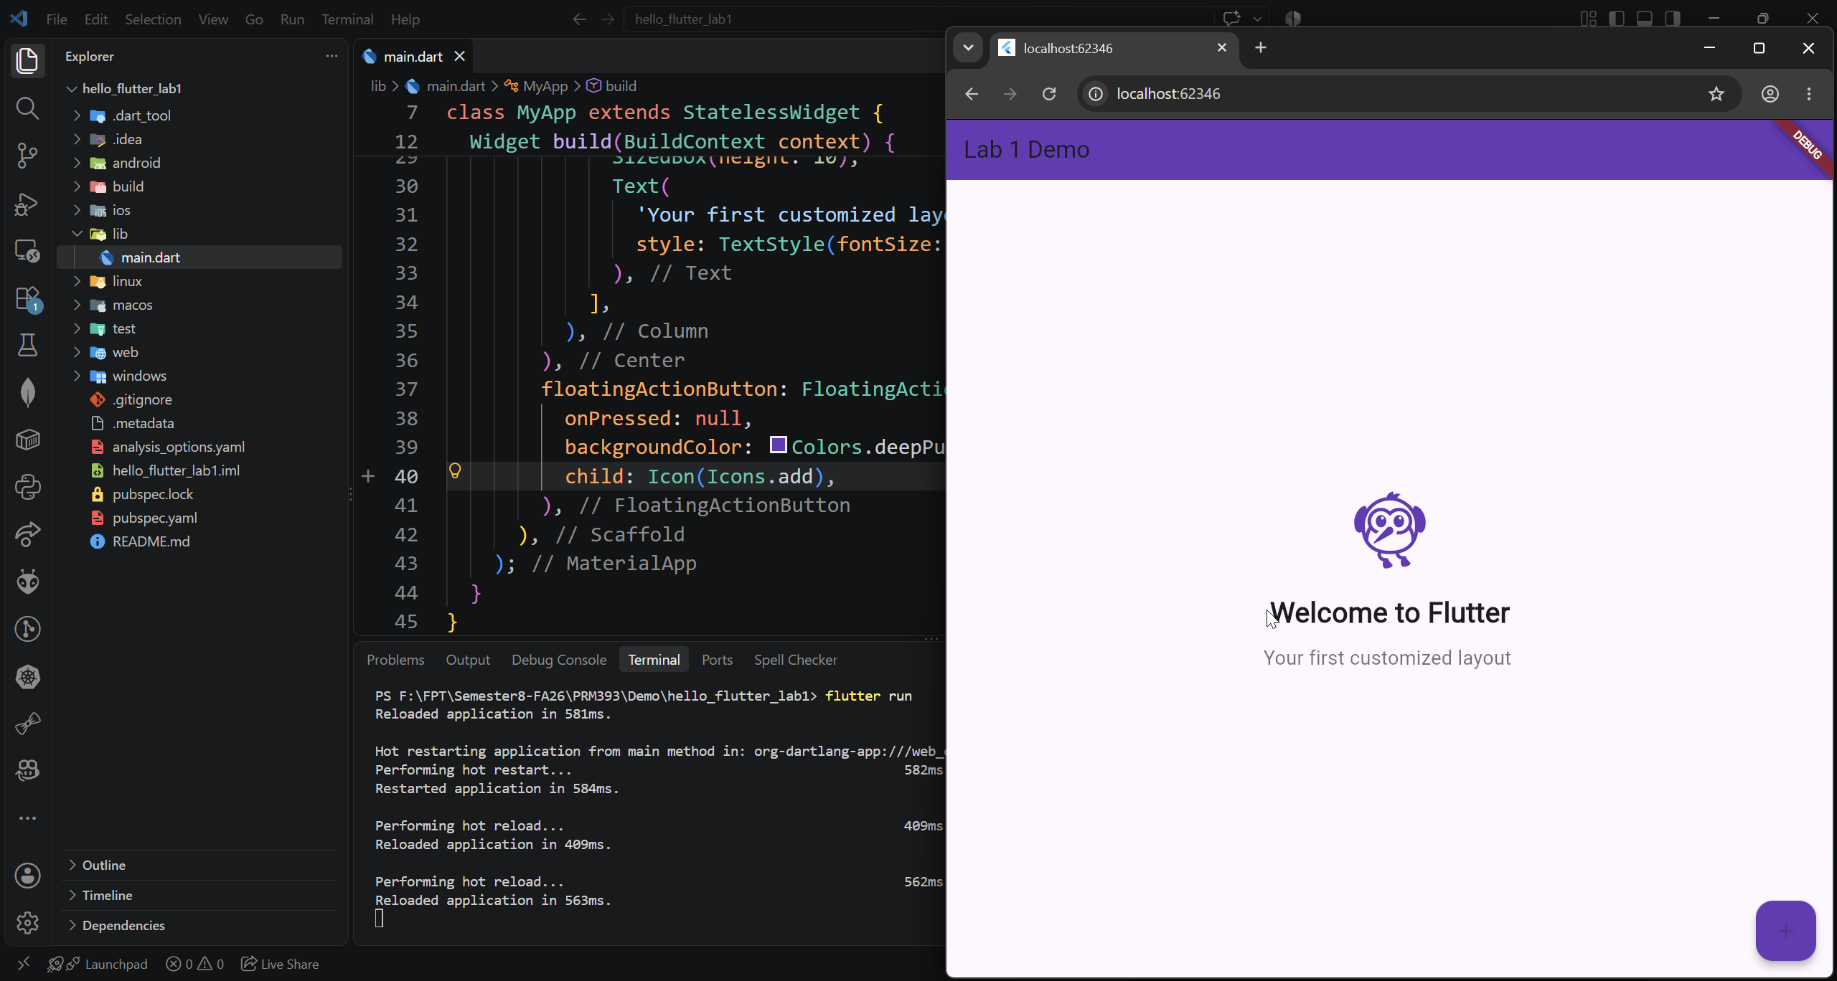
Exercise 4 – Reflection Questions
- What is the purpose of the flutter doctor command?
- flutter doctor checks the Flutter development environment and shows whether Flutter, Android SDK, IDEs, and other required tools are installed and configured correctly. It also reports any problems that need to be fixed.
- What file acts as the entry point of a Flutter application?
- The entry point is lib/main.dart. It contains the main() function, where the Flutter application starts.
- Explain the difference between Hot Reload and Hot Restart.
- Hot Reload: Applies code changes to the running app without restarting it. The current state of the application is usually preserved.
- Hot Restart: Restarts the Flutter application from the beginning. The current state is lost.
- How does runApp() build the widget tree?
- runApp() takes the root widget and attaches it to the Flutter framework. Flutter then builds the widget tree starting from this root widget and creates the corresponding UI.
Example:
void main() {
runApp(const MyApp());
}
- Describe how Flutter’s architecture enables cross-platform development.
=> Flutter uses a single codebase written mainly in Dart and provides its own widget framework and rendering engine. The same Flutter code can be used to build applications for platforms such as Android, iOS, Web, Windows, macOS, and Linux, reducing the need to create separate applications for each platform.
4. Expected Results
- Successful setup of Flutter environment
- Ability to create and run Flutter projects
- Understanding of widgets, layout, and hot reload
- Complete screenshots for all required steps

5. Submission
- Zipped Flutter project folder or GitHub link
- All screenshots
- Written answers for reflection questions

